3.2 CALCULATION PROCEDURE

Unlike the API RP 14E the erosion corrosion rate is calculated with the thickness loss detected by using the ultrasonic thickness tester.

$V_{e}=\frac{Thickness loss (mm)}{time (year)}$*(3)*

The thickness measured per month is using the Ultrasonic thickness tester is now plotted against the time.

Figure 3.6: Graph of Thickness against Time

Figure 3.7: Graph showing the trend of erosion

From the trend in figure 3.7 a straight line equation was generated corresponding to the equation below:

$y=mx+c$*(4)*

Generated equation:

$$y= -1.4213x+11.261$$

“m” Is the slope, representing the ratio of thickness to time

From Pythagoras theory

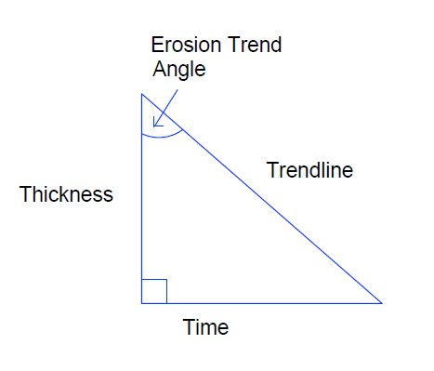

Recall:

$m=\frac{thickness change}{time change}$*(5)*

Also,

$tanθ=\frac{opposite}{adjacent}$*(6)*

Therefore,

$tanθ_{e}=\frac{1}{-m}$*(7)*

$θ_{e}=\tan^{-1}(-m^{-1})$*(8)*

The negative sign makes up for the negative slope effect.

$$θ_{e}=erosion trend angle$$

From the generated “m”

$$θ_{e}=\tan^{-1}(-{(-1.4213)}^{-1})$$

$$θ_{e}=35°$$

100 runs of erosion trend angle analysis where carried out on field X at different points of flowlines and manifolds using the ultrasonic thickness test data. Which eventually led to the conclusion of ranges of high, low and no erosion corrosion effects for quick decision making.

The Erosion trend factor $f_{e }$ is gotten from the ratio of the Erosion trend angle $θ_{e}$ to that of the maximum trend angle $θ_{e,max}$ for a non-corroding material.

$f_{e }=\frac{θ_{e}}{θ_{e,max}}$*(9)*

3.2 Software Flow Chart

CALCULATE EROSION TREND ANGLE (ETA)

CALCULATE EROSION CORROSION RATE

INPUT THICKNESS (mm)

INPUT TIME (YEAR)

INPUT TIME (YEAR)

INPUT THICKNESS (mm)

PLOT EROSION TREND

EROSION RATE (mm/yearr)

NEGATIVE TREND (-m)

WRONG DATA

NO

CLEAN UP

YES

SHOW ETA AND ETF

NEW EQUIPMENT

ETF?

>30ᵒ <30ᵒ

NOT CRITICAL

CRITICAL